**“Experiment 1.1”**

Student Name: **SUMIT KUMAR** UID: **20BCS8226**

Branch: **CSE** Section/Group: **808 A**

Semester: **5th** Date of Submission: **05-09-22**

Subject Name: **Machine Learning Lab** Subject Code: **CSP-317**

1. **Aim:**

Implement Exploratory Data Analysis on any data set.

1. **Software/Hardware Requirements:**

Windows 7 & above version

1. **Tools to be used:**

* Google colab
* Python programming language

1. **Implementation:**

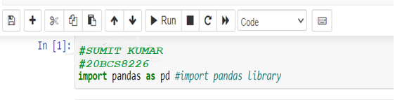

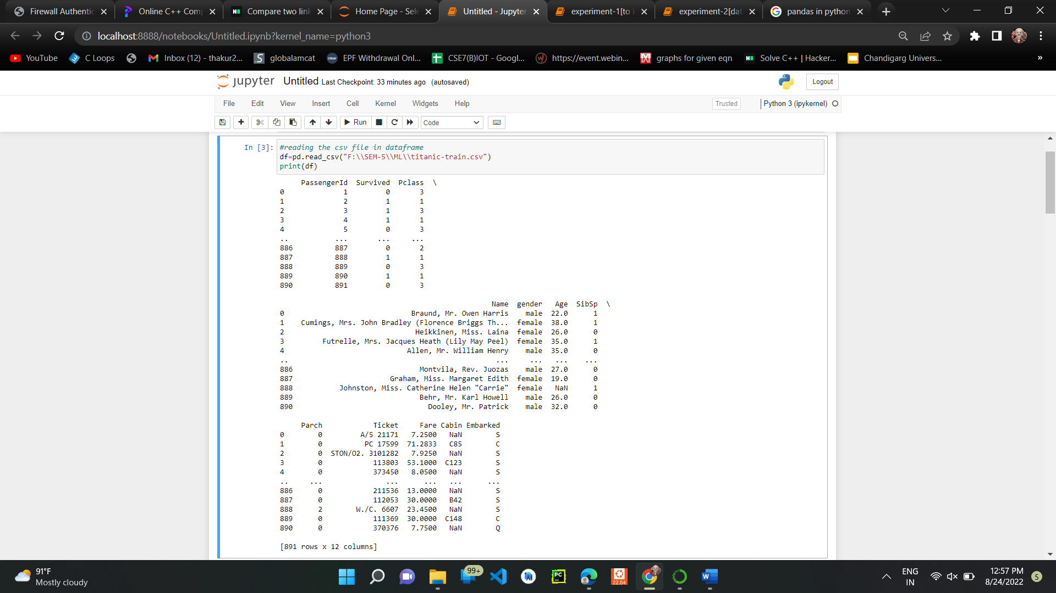

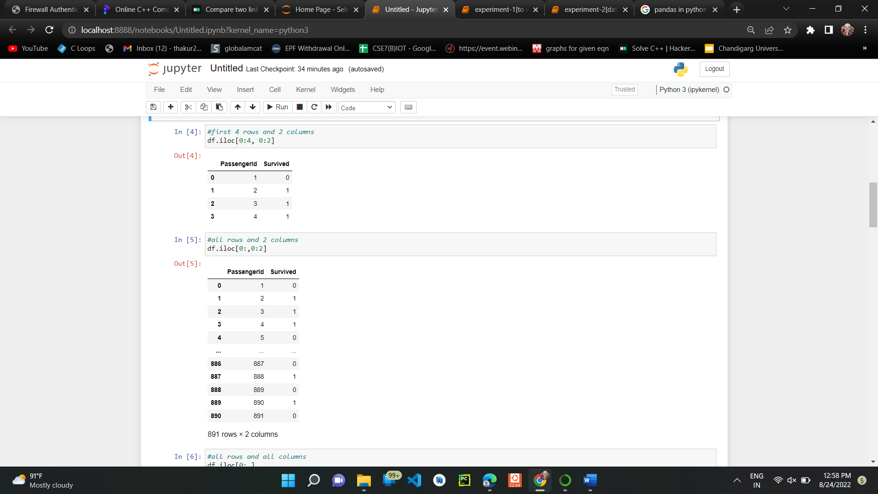

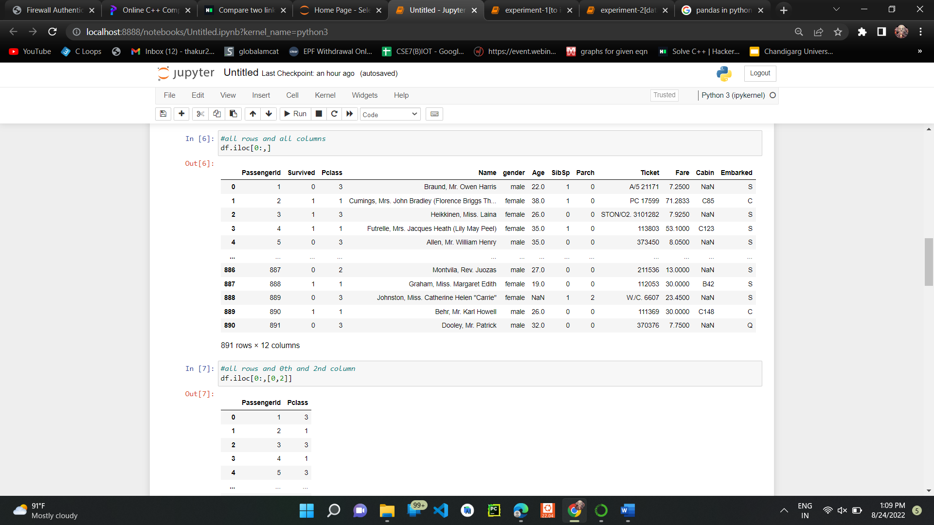

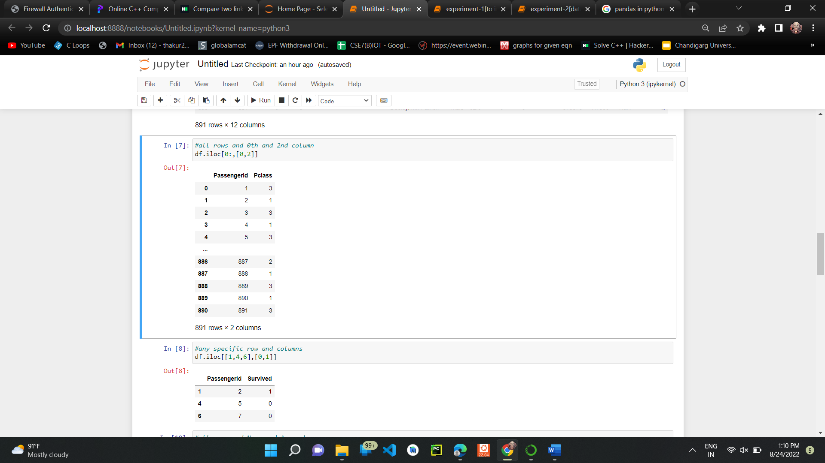

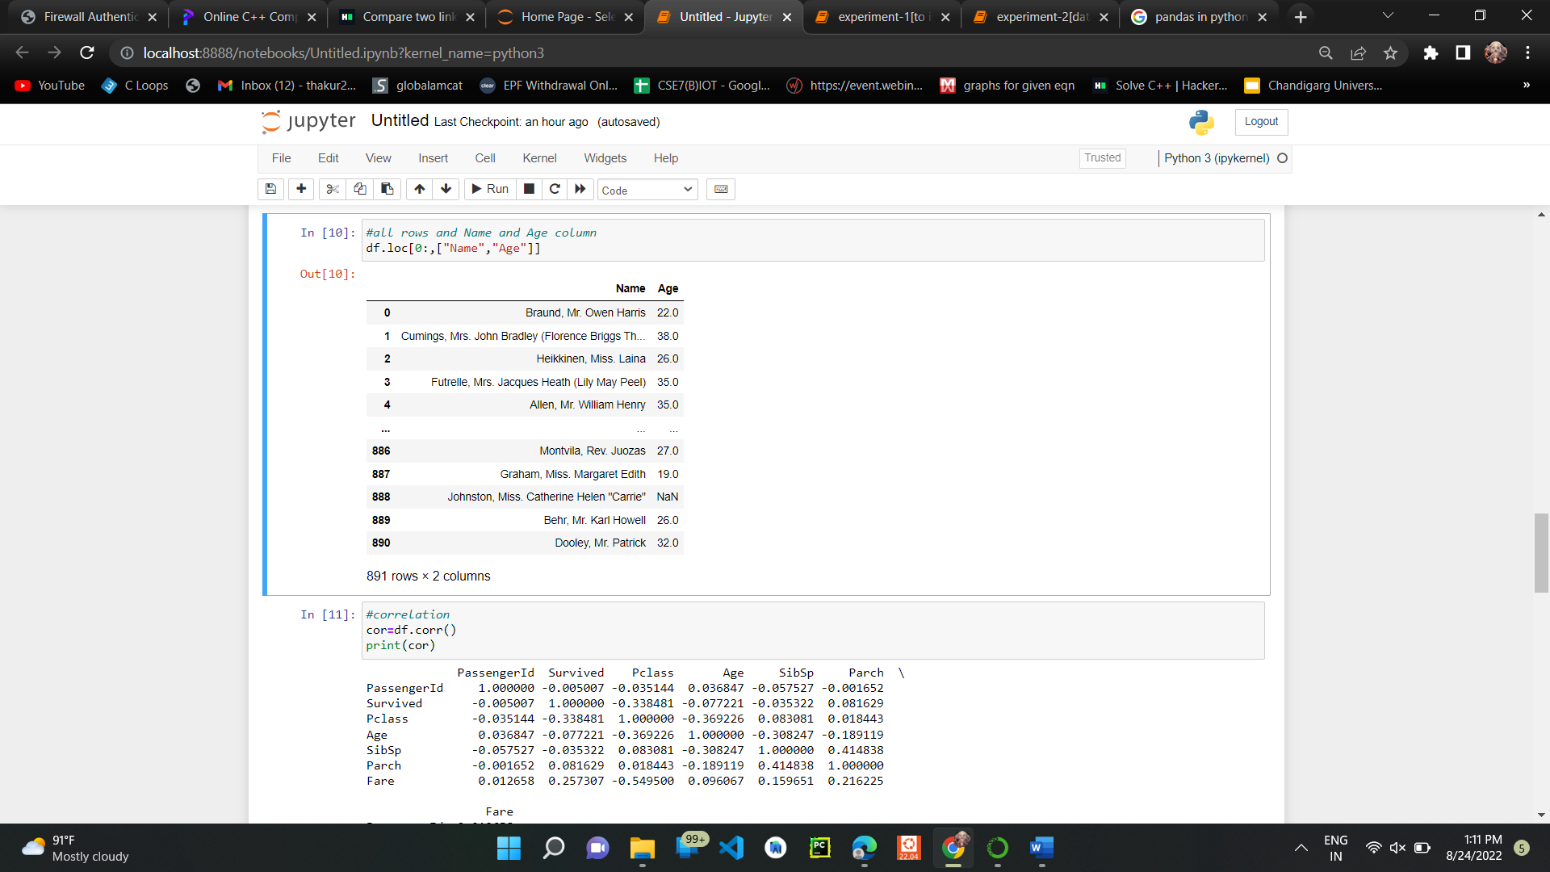

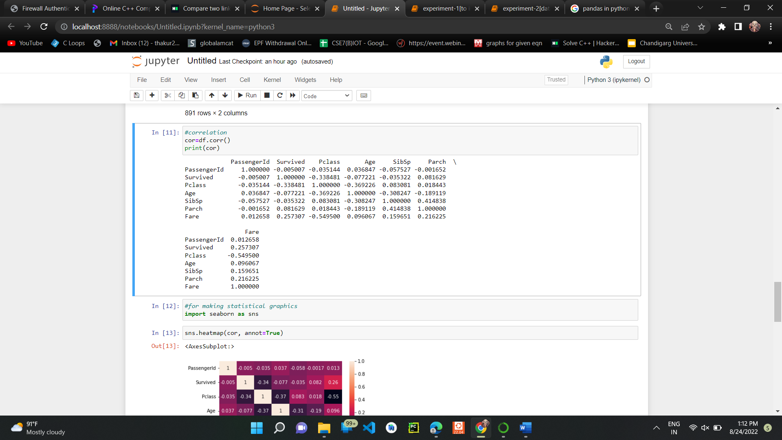

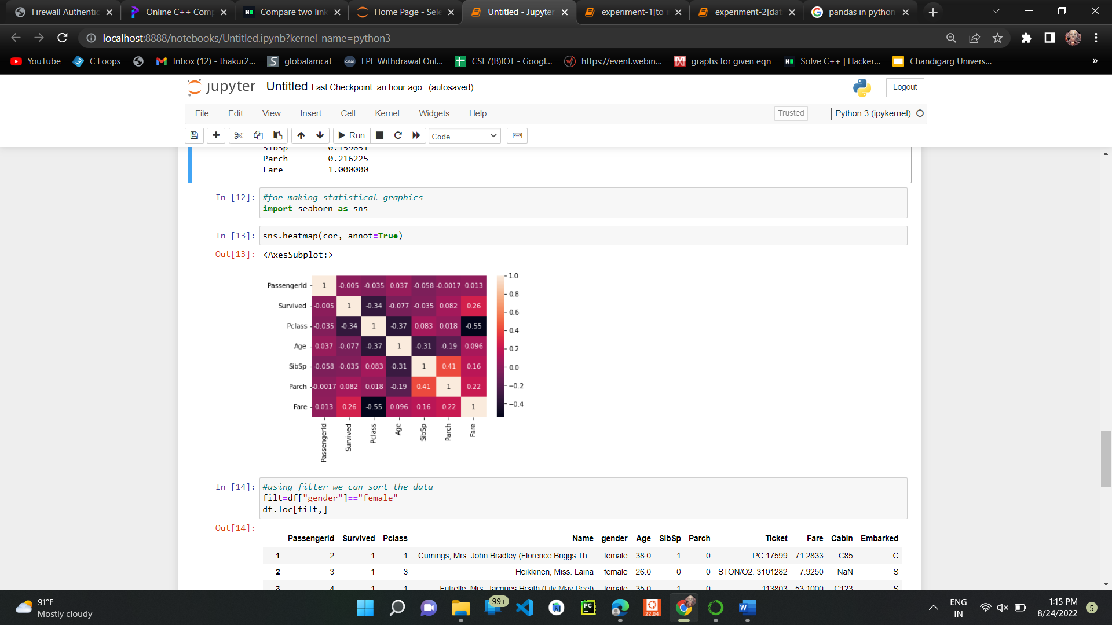

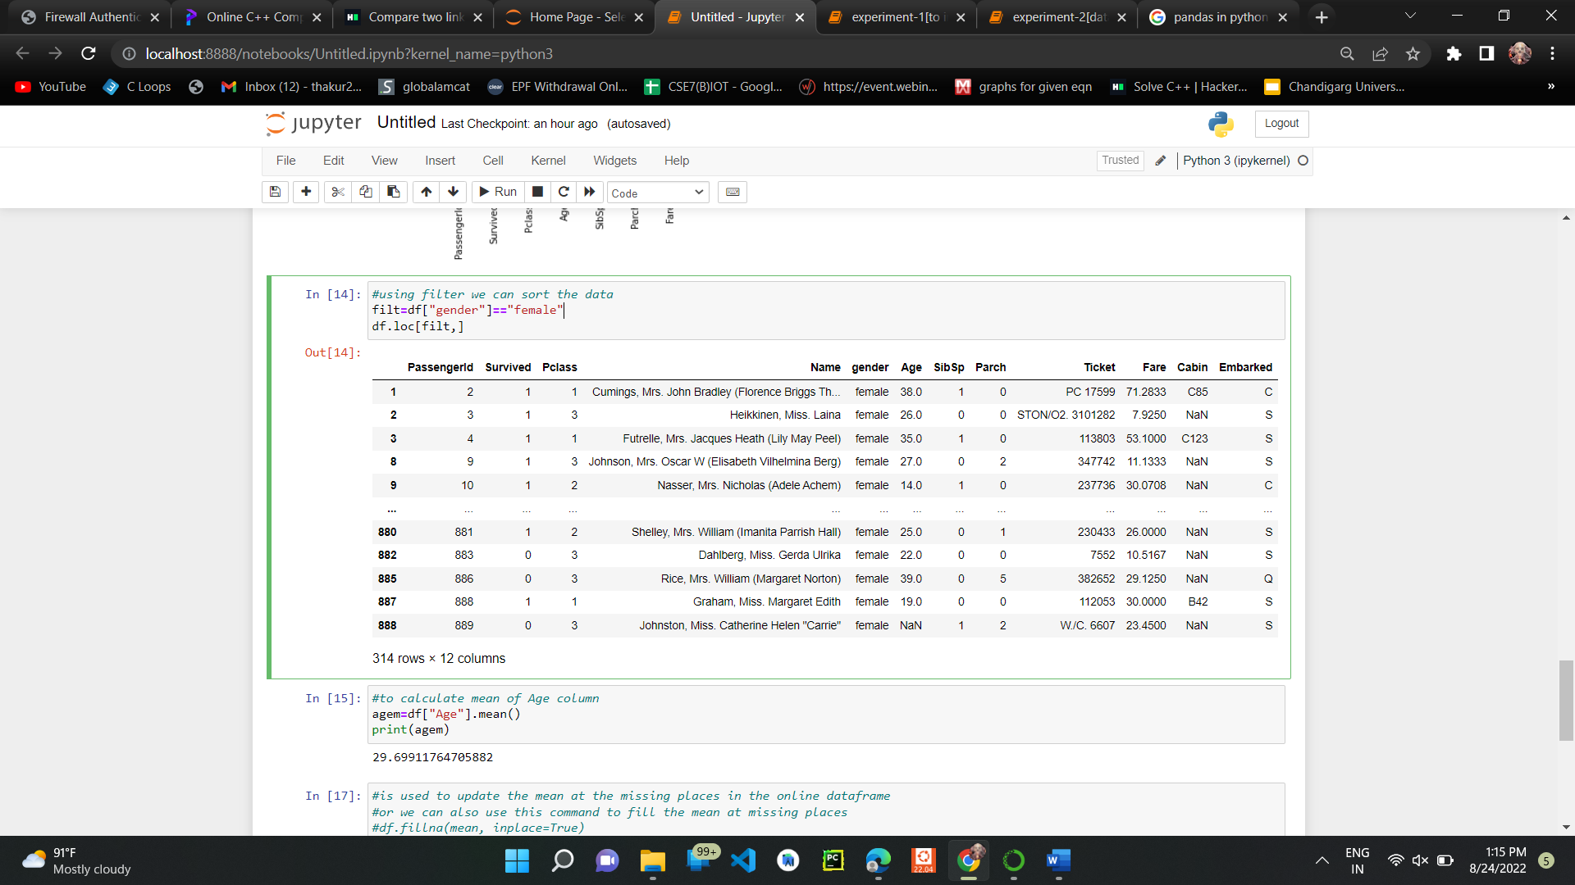

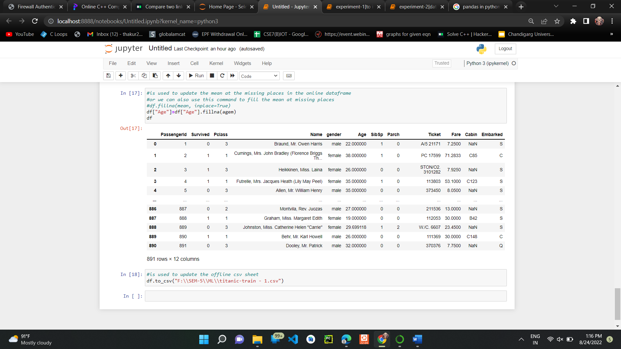

**Output:**

**Before updating the csv sheet:**

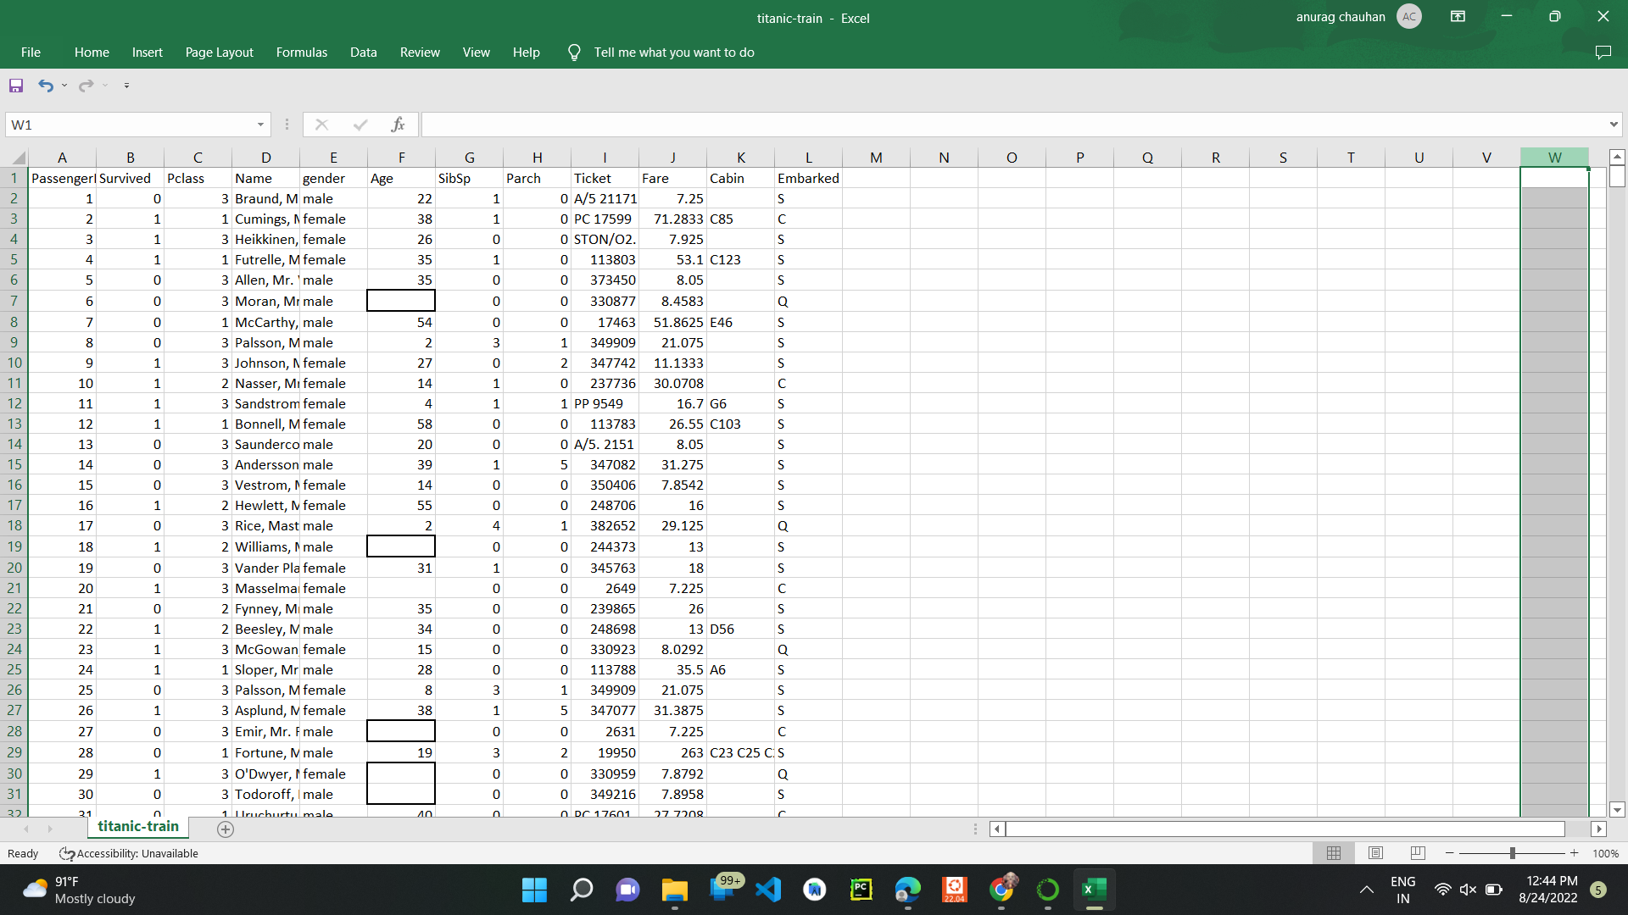

**After inserting the mean at missing value places in the csv sheet:**

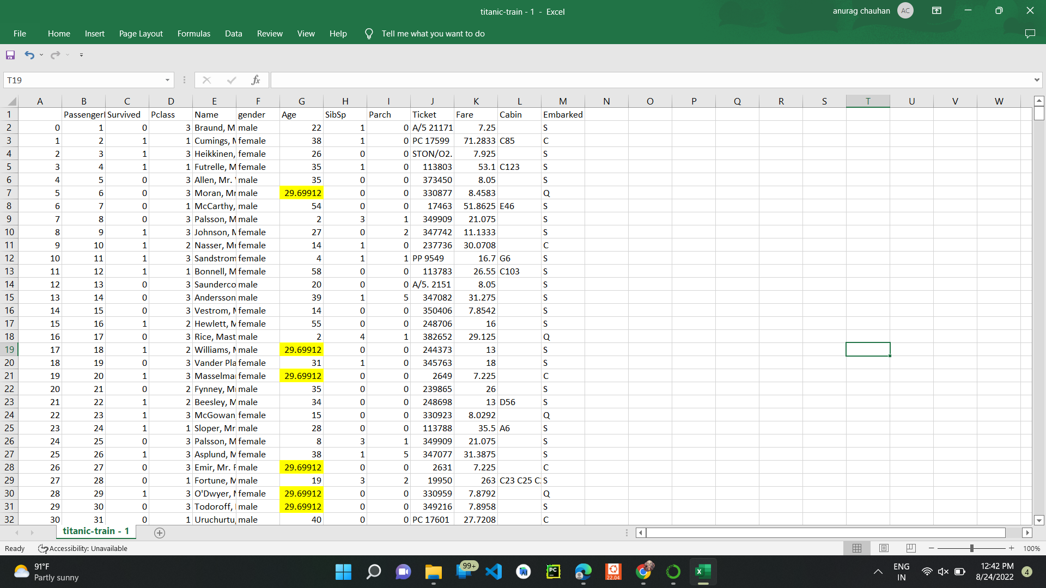

**Learning outcomes (What I have learnt):**

1. Understanding of Exploratory Data analysis.
2. Able to analyze different datasets with the help of python and pandas library.
3. Learning about different library/packages of python.
4. Learning about the different methods, that are needed to analyze the given dataset.
5. Learning of different Machine Learning Functions.

**Evaluation Grid:**

|  |  |  |  |
| --- | --- | --- | --- |
| **Sr. No.** | **Parameters** | **Marks Obtained** | **Maximum Marks** |
| **1.** |  |  |  |
| **2.** |  |  |  |
| **3.** |  |  |  |
|  |  |  |  |